**Web Scraping Report: CoinMarketCap**

By: Karamova Nargiz

**1. Introduction**

The objective of this task was to scrape data from CoinMarketCap, a popular website that provides real-time information on cryptocurrency prices, market cap, trading volumes, and other related statistics. Web scraping is a crucial skill for data analysts, as it allows them to gather data from various sources automatically, which can then be analyzed and used for different purposes. In this report, I detail the process of collecting cryptocurrency data from CoinMarketCap using Octoparse.

**2. Tools and Method Used**

For this task, I used Octoparse, a no-code web scraping tool that allows users to extract data visually without needing programming skills. Octoparse is user-friendly and offers an easy interface for selecting the data to scrape, defining rules, and exporting the data. I chose Octoparse because of its simplicity and the ability to automate the scraping process without writing code.

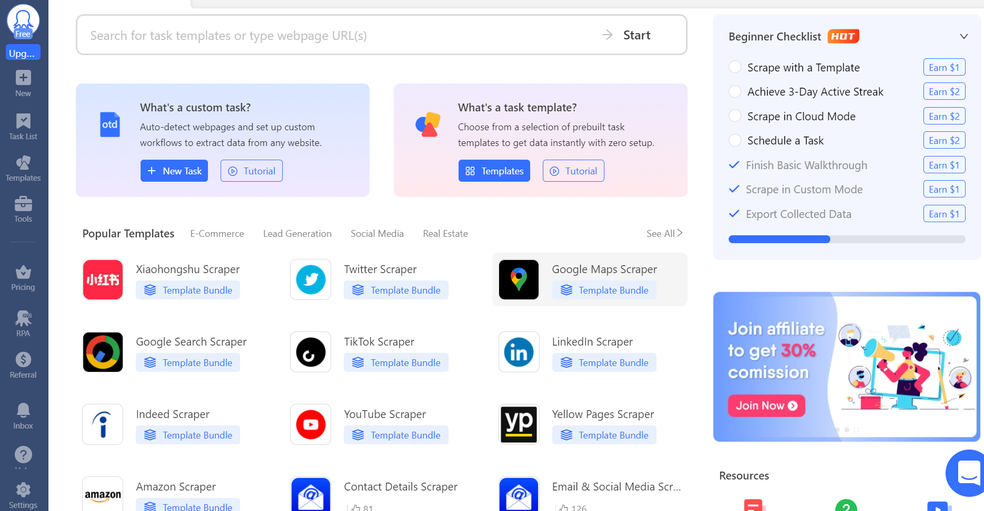

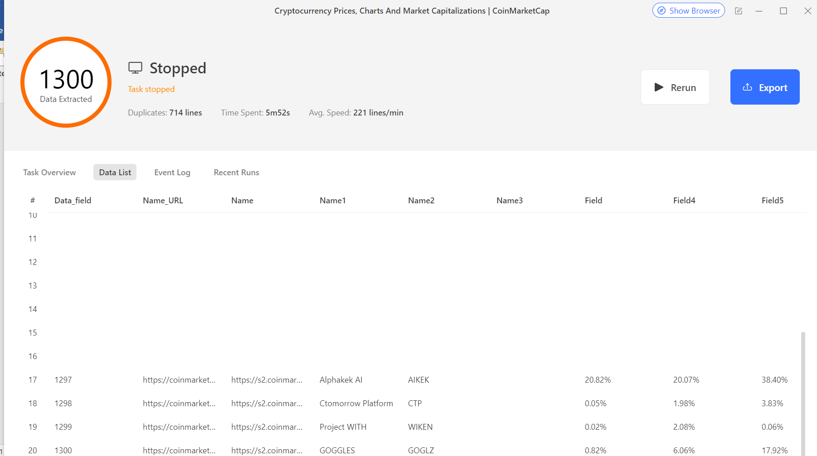

**3. Data Collected**

The following data points were extracted from CoinMarketCap:

1. Cryptocurrency Name (e.g., Bitcoin, Ethereum)
2. Price (in USD)
3. Market Capitalization (Market cap)
4. 24-hour Trading Volume
5. Circulating Supply
6. Price Change (24-hour percentage change)

**4. Scraping Process**

The steps for scraping data from CoinMarketCap were as follows:

1. Create a New Task: I entered the URL of CoinMarketCap in Octoparse and started a new task.
2. Select Data Elements: I selected the relevant data points from the website, including cryptocurrency names, prices, market cap, and 24-hour trading volumes.
3. Define Extraction Rules: I set up extraction rules in Octoparse to automatically scrape the data for each cryptocurrency.
4. Run the Scraping Task: I ran the task, and Octoparse automatically extracted the data.
5. Export Data: After the data extraction was complete, I exported the data in CSV or EXCEL format for analysis.

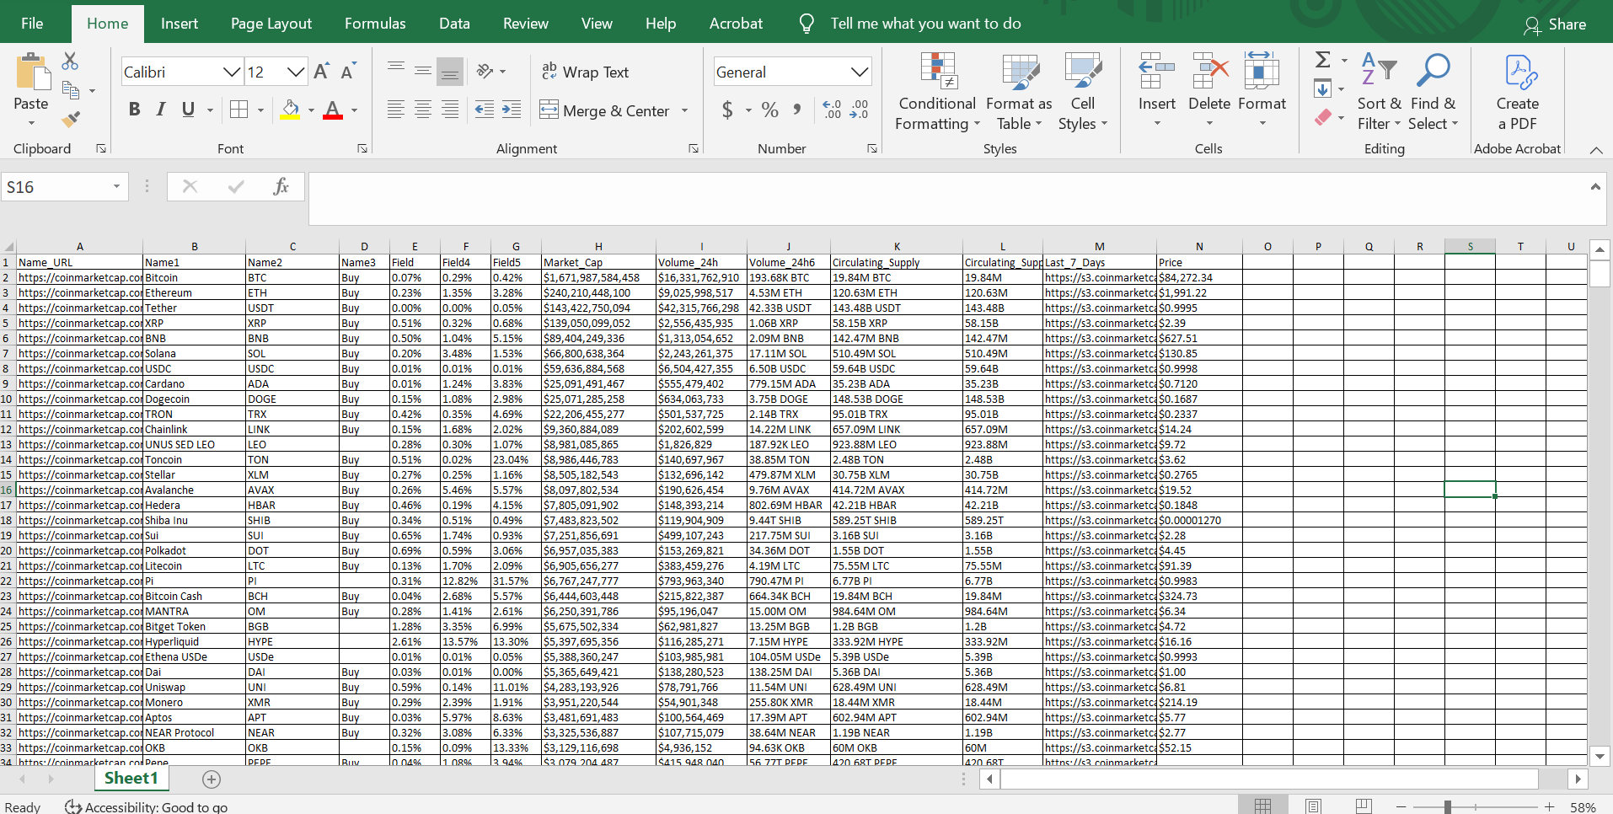

5. Results and Analysis

The extracted data was accurate and relevant for analysis. Key findings include:

Cryptocurrency Prices: The prices were accurate and updated in real-time. This data can be used for market trend analysis and price comparison.

Market Capitalization: The ranking of cryptocurrencies by market cap was consistent, with Bitcoin and Ethereum at the top.

Trading Volumes: The trading volumes were also accurate and helped to understand the market activity and liquidity for each cryptocurrency.

This task demonstrated the effectiveness of web scraping using Octoparse to collect cryptocurrency data from CoinMarketCap. The data collected can be used for further analysis of market trends, price fluctuations, and the overall cryptocurrency market.